October 7, 2011

Dear Patrons of the Blessed Margaret of Castello Guild and Shrine,

The grace of our Lord Jesus Christ, and the love of God, and the communion of the Holy Spirit be with you! As I write this letter on the Feast of Our Lady of the Rosary, my prayer for you is that you always rejoice in the protection and maternal love of the Blessed Virgin, to whom Blessed Margaret turned for help and rejoiced in her Mother’s love!

There is good news to report both on a local level and universally. Let me begin with the good things that are happening here at her Shrine before explaining the current status of Blessed Margaret’s cause for canonization.

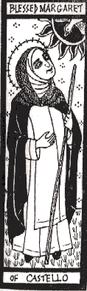

The Shrine of Bl. Margaret engages in charitable acts under her patronage with the particular emphasis of helping those deemed “unwanted” while promoting devotion to Little Margaret. We continue to be busy and active in the day to day work of the Guild, such as answering your letters, lighting candles for your intentions, and praying for Blessed Margaret’s powerful intercession over your families and friends. The Dominican friars remember the intentions of the Guild members in our daily prayers. The friars celebrate a monthly Mass at Saint Patrick Church, home of the Shrine, for the intentions of the Guild. The friars offer a special Christmas Octave of Masses for the intentions of the members of the Blessed Margaret Guild from December 25 to January 1. Every Wednesday, the entire parish community prays the Bl. Margaret novena prayers and venerates the relic of her incorrupt heart. Through your generous donations to both the Bl. Margaret Guild and Little Margaret’s Charity last year we were able to distribute $30,065 to various charities and needs. This is almost 25% less than last year, but still an impressive sum considering the present economy. Thank you for your generosity!

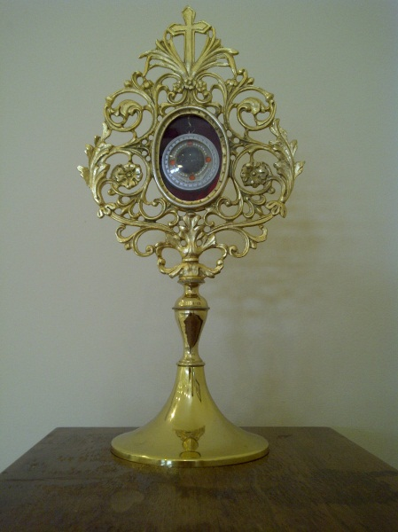

I had explained to you in the spring mailing my great joy in being able to offer the Holy Sacrifice of the Mass for you and the members of the Guild in Città di Castello at the altar containing the incorrupt body of our beloved Little Margaret. That February trip, having had to attend meetings for national pilgrimage directors to Lourdes,* was a perfect opportunity to visit the promoter of Blessed Margaret’s cause for canonization as well as to pray at her Shrine in Castello. Be assured that I continue to send prayers for you from her Shrine here in Ohio, where the relic of her incorrupt and ever-loving heart resides, as well as prayers for Little Margaret’s canonization.

Relic from Bl. Margaret’s incorrupt

heart here at St. Patrick’s Church * See **www.lourdes-pilgrimage.com** for information on the 2012 U.S. National Rosary

(the relic is the size of a quarter) Pilgrimage to Lourdes.

Fr. Francesco Ricci, O.P., Promoter for Dominican Saints in Rome, is the one responsible for pursuing Bl. Margaret’s cause for canonization and is deeply devoted to her. Fr. Francesco reports that the majority of the work for Little Margaret’s canonization is complete and is very grateful to the Guild for all our financial support. Everything is documented and prepared for the final brief to be presented to the Congregation for the Causes of Saints, except for one thing … a new miracle.

We have all experienced the powerful intercession of Little Margaret. We also know of her many miracles recorded in history. However, Bl. Margaret’s canonization cause simply requires a recent and approved miracle. Here at the Shrine of Blessed Margaret in Columbus, I receive reports of miracles all the time, but a suitable miracle has to be truly wondrous, incapable of a natural explanation, solely and verifiably entrusted to the saint’s intercession, and accurately documented with all the appropriate medical records and multiple attestations. If you know of a miracle attributed exclusively to the intercession of our little patron of the unwanted, document everything and contact me. In the meantime, please continue to pray for Blessed Margaret’s canonization.

God greatly values our prayers. There are many things that God will only do with our cooperation – so He has given us the gift of prayer. When the Apostles asked our Lord to teach them how to pray, He gave them the Our Father – a prayer comprised of seven petitions. Please pray for the elevation of Bl. Margaret to the honor of sainthood! Continue to spread devotion to her by sharing your knowledge of her with your friends. You may also wish to contribute to the Guild’s efforts, especially in that we are poised to help Fr. Francesco with the costs of the canonization process whenever God blesses us with a miracle in honor of Little Margaret.

It is a long standing tradition that the director of the Shrine comes to you and the rest of the Guild once a year to make an annual plea for your generous donations for the works of the Blessed Margaret of Castello Shrine. Today I am once again asking you to join in the work of the Shrine, the promotion of life, and the canonization of our beloved Little Margaret by your generosity. Our annual Charity Appeal letter also comes with a blank form for you to send us the names of family and friends who may want to obtain information on Blessed Margaret. (Please know that if you provide us with someone’s name we will send information only once, and will not add him or her to our mailing list until they ask us to do so.) Also if you would like to place your intentions directly on the altar shrine of Blessed Margaret, please fill out the enclosed form and send it to us, with or without a contribution.

I would like to thank you for your continued support and prayers. Please know that you and your families and friends are in my prayers. May you experience the affectionate and powerful prayers of Little Margaret throughout your life. God bless you!

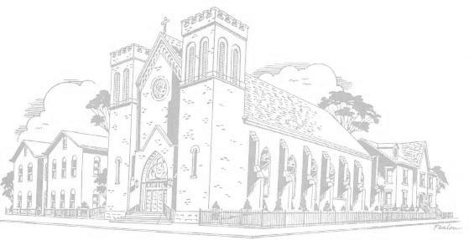

In our Lord, our Lady, and Blessed Margaret,

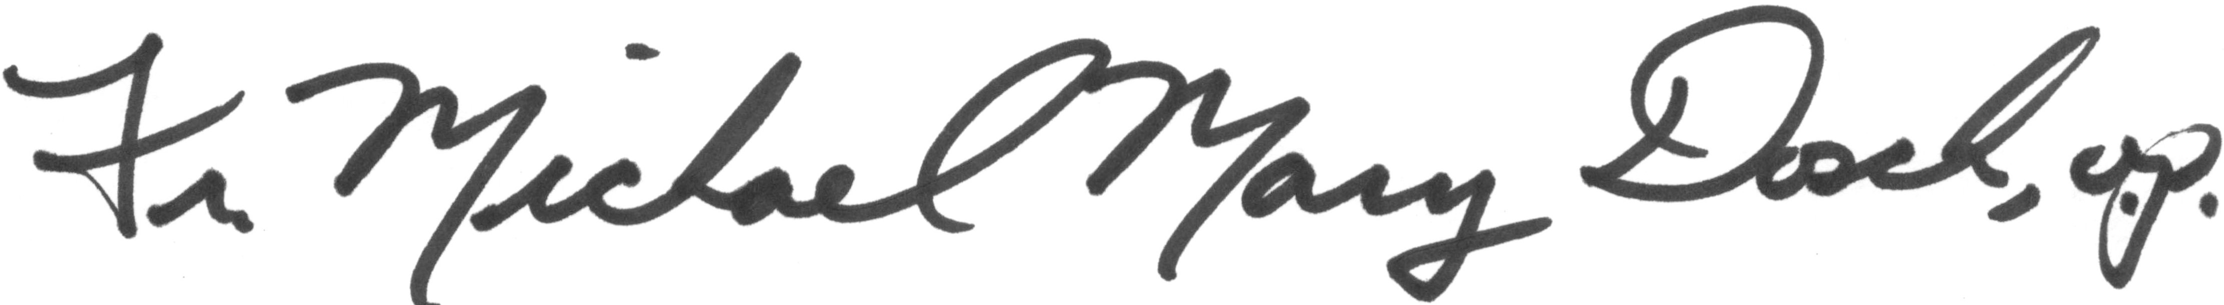

Rev. Michael Mary Dosch, O.P.

Shrine and Guild Director

St. Patrick’s Church and Shrine to Bl. Margaret

Columbus, Ohio

Fr. Michael Mary Dosch, O.P., Director of the Shrine of

Bl. Margaret of Castello in

St. Patrick Church,

Columbus, Ohio